Patient Information

Date___________________________
Patient Name_________________________________________________
First M Last

Date of Birth_____________________ Sex Male Female
Patient SSN#____________________________
Address______________________________________________________
City ____________________________ State _____Zip _______________
Cell Phone________________ Home Phone ________________________
E-mail_______________________________________________________
Occupation __________________________________________________
Employer/ School______________________________________________
Married Single Widowed Divorced Separated Minor
Spouse’s Name________________________________________________
Do you have children? Yes No How many?__________________ How did you hear about us?_____________________________________
New Patient Welcome Form

Health Insurance

Policy Holder _________________________________________________
First M Last

Policy Holder’s Date of Birth_______________ Sex Male Female
Insurance Company____________________________________________
Policy # ___________________________Group #___________________
Relationship to the patient Self Spouse Child Other
- If you selected “self” please stop here and proceed to the next section.
- Please give insurance card to front desk for copying

Secondary Health Insurance

Policy Holder _________________________________________________
First M Last

Policy Holder’s Date of Birth_______________ Sex Male Female
Insurance Company____________________________________________
Policy # ___________________________Group #___________________
Relationship to the patient Self Spouse Child Other

Patient Condition

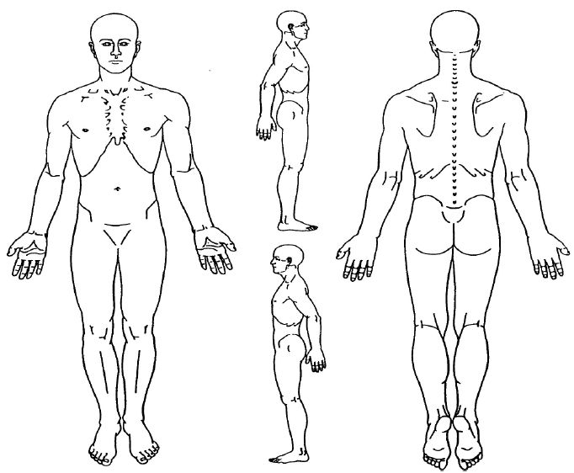What is your main complaint? ____________________________________________ Please shade the complaint area(s).
How long have you had this problem? _____________________________________
What started the problem?_______________________________________________
Please indicate any other symptoms that you have experienced:
Dizziness Memory Loss Headaches Numb Feet/ Toes
Irritability Ears Ringing Back Pain Difficulty Sleeping
Fatigue Jaw Problems Chest Pain Arm/ Shoulder Pain
Leg Pain Back Stiffness Blurred Vision Numb Hand/ Fingers
Tension Low Back Pain Neck Stiffness Shortness of Breath
Nausea Buzzing in Ear Neck Pain Upset Stomach

Other______________________________________________________

Health Questionnaire

Do you have a personal physician? Yes No
Physician Name_______________________________________________
Are you currently under the care of a physician? Yes No
Explain_______________________________________________________
_____________________________________________________________
Have you ever been treated by a chiropractor? Yes No
Chiropractor’s Name___________________________________________
Explain_______________________________________________________
___________________________________________________________
When was the last date of your last:
Physical Exam ________________ MRI ____________________
Spinal X-Ray _________________ CT Scan _________________
Bone Scan ___________________ Other ___________________
For Woman:
Are you taking birth control? Yes No
Are you currently nursing? Yes No
Are you pregnant? Yes No
If yes, due date? ___________________

Have you experienced or are you currently experiencing any of the following conditions?
Put “C” for any current conditions
Please check all that apply Cancer Glaucoma Leukemia Rheumatism
Abnormal Bleeding Chemotherapy Gout Liver Disease/Problems Scarlet Fever
Alcoholism Chicken Pox Hay Fever Low Blood Pressure Sciatica
Allergies Colitis Headaches Lupus Scoliosis
Alzheimer’s Congenital Heart Defect Head Injury Migraine Seizures
Anemia Depression Heart Disease Mitral Valve Replacement Shingles
Arthritis Difficulty Breathing Hemophilia Obesity Sickle Cell Disease
Artificial Bones/ Joints Drug Abuse Hepatitis Pacemaker Sinus Problems
Artificial Valves Epilepsy Herpes Persistent Cough Sleep Disorder
Asthma Emphysema High Blood Pressure Psychiatric Problems Stroke
Blood Clots Fainting Spells HIV/ AIDS Radiation Treatment Thyroid Problems
Blood Transfusion Fatigue Kidney Problems Rheumatic Fever Other:_______________

Additional Health Information

Please list any prescriptions or over the
counter drugs you are currently taking.
___________________________________
___________________________________
___________________________________
___________________________________
___________________________________

Please list any vitamins or herbs
you are currently taking.
___________________________________
___________________________________
___________________________________
___________________________________
___________________________________

Please list all known allergies and any
medications you have reactions to.
___________________________________
___________________________________
___________________________________
___________________________________
___________________________________

Authorization and Medical Release
I affirm that the information I have given is correct to the best of my knowledge. The information I have provided will remain confidential, and I understand that it is my responsibility to inform this office of any changes in my medical status.

I understand that the health and accident insurance policies are an agreement between an insurance carrier and myself. Furthermore, I understand that this chiropractic office will prepare any necessary reports and forms to assist me in making my collections from the insurance company. Any amount authorized to be paid directly to this chiropractic office will be credited to my account upon receipt. However, I clearly understand and agree that all services rendered are charged directly to me, and I am personally responsible for payment. I also understand that if I suspend or terminate my care and treatment, any fees for professional services rendered to me will be immediately due and payable. I hereby authorize Fox Chiropractic and Wellness Center to furnish all the information required by the insurance company concerning my injury or illness. I hereby authorize the doctor to treat my condition as he deems appropriate and to grant full disclosure for all previous or concurrent care. In addition, I agree to grant full indemnity to Fox Chiropractic and Wellness Center from all liability for any medical complications incurred resulting from or related to pre-existing conditions medically diagnosed or otherwise not disclosed by me.

Patient or Guardian Signature______________________________________________ Date __________________
Print Guardian Name _________________________________________ Relationship to Patient_______________
Informed Consent
Chiropractic Care with Dr. Brandon D. Fox, D.C.

I hereby request and consent to the performance of chiropractic adjustments and other chiropractic procedures, including various modes of physical therapy and diagnostic X-rays, on me (or on the patient named below, for whom I am legally responsible) by the doctor of chiropractic named above and/or other licensed doctors of chiropractic who now or in the future work at the clinic or office listed below or any other office or clinic.

I understand and am informed that, as in the practice of medicine, in the practice of chiropractic there are some risks to treatment. Please feel free to discuss directly with Dr. Fox any questions or concerns you may have.

Disc Herniation: Disc herniations are frequently and successfully treated by chiropractors. Occasionally, chiropractic treatment may aggravate the problem, and rarely surgical intervention may become necessary if the chiropractic care is not successful. Very rarely, chiropractic adjustments may also cause a disc problem if the disc is already damaged or in a weakened condition. These problems occur so rarely that there is no available statistical information to quantify their probability.

Soft Tissue Injury: Soft tissues primarily refer to muscles, tendons, and ligaments. Rarely, a chiropractic adjustment, traction, massage, etc. may overstretch or tear some muscle, tendon, or ligament fibers. The result is a temporary increase in pain and a brief, temporary increased need for treatment, but in most every case there are no long-term effects to the patient. These problems occur so infrequently and are so rare that there are no available statistics to quantify their probability.

Rib Fracture: Rarely, chiropractic adjustment(s) may crack a rib bone. This risk is increased in elderly, osteoporotic bones. We adjust all patients very carefully, especially our elderly patients with osteoporosis. These problems of rib fracture occur so rarely that there are no available statistics to quantify their probability.

Soreness: Chiropractic adjustments, traction, massage therapy, exercise, etc. may result in temporary increase in soreness. This is usually a very temporary symptom. It is not dangerous, but please tell Dr. Fox about it.

Stroke: Stroke is VERY uncommon, but it is the most serious problems associated with vertebral manipulation of the cervical spine (neck). In the May, 1994 Chiropractic Report, they discuss the problem. “By any medical standard, chiropractic cervical adjustment is an extremely safe treatment. Vertbral artery injury causing stroke is the only serious potential complication. There is a risk rate (incidence) of about .0002% or one case in two million.” In another study, (Journal of CCA, Vol. 37, No. 2, June 1993) they estimate that the risk of this type of stroke is .0003%, one in three million.

Other Problems: There may be other problems or complications that might arise from chiropractic treatment, other than those noted above.
I have read, or have had read to me, the above consent. I have also had an opportunity to ask questions about its content, and by signing below I agree to the above-named procedures. I intend this consent form to cover the entire course of treatment for my present condition and for any future condition(s) or which I seek treatment.

Patient Name______________________________________________________

Patient/Guardian Signature___________________________________________ Date_________________

Personal Medical Information Consent Form - HIPPA

The Health Insurance Portability Accountability Act of 1996 (HIPPA) requires that we receive your permission before we use the personal information in your medical records for any reason. This consent form gives us permission to use your Protected Health Information (PHI) to carry out treatment, receive and/or as part of health care operations, of our practice. HIPPA also requires us to have a written notice of our privacy policy describing how medical information about you may be used and disclosed. If you so desire, this written notice is available at the front desk for you to read. You have the right to revoke, in writing, this consent form at any time, although any services performed prior to the revocation of this consent are covered by this consent.

Patient/Guardian Signature___________________________________________ Date_________________

RESTRICTIONS:
Right to Revise Privacy Practices: As permitted by law, we reserve the right to amend or modify our privacy policies and practice. These changes in our office’s policies and practices may be required by changes in federal and state laws and regulations. Upon receipt, we will provide you with the most recent notice on an office visit. The revised policies and practices will be applied to all protected health information we maintain.
~Dr. Brandon D. Fox, D.C. and Staff

